1. Say your name.  
     
   Di non ou.
2. Spell your name.  
     
   Eple non ou.
3. Print your name.  
   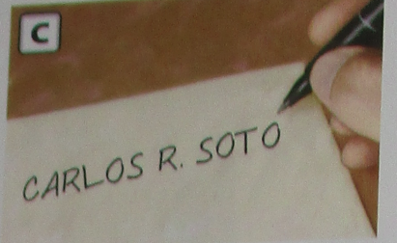  
   Enprime non w.
4. Sign your name.  
   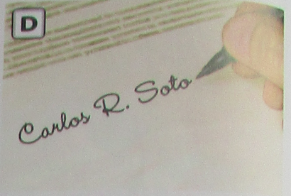  
   Siyen non w.
5. Name:  
   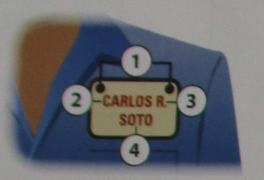  
   Siyati:
6. First name  
     
   Non
7. Middle Initial  
     
   Inisyal dezèm non
8. Last name  
     
   Siyati
9. Address  
   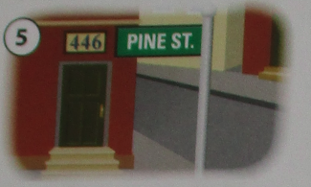  
   Adrès
10. Apartment number  
    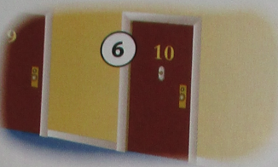  
    Nimewo apatman
11. City  
    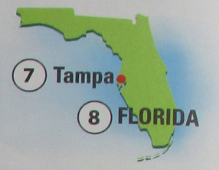  
    Vil
12. State  
      
    Eta
13. ZIP code  
    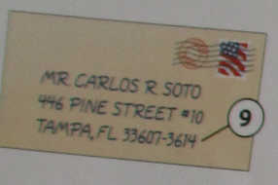  
    Kòd postal
14. Area Code  
    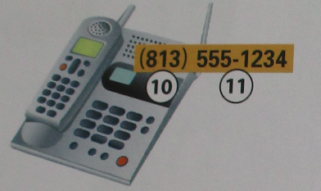  
    Kòd rejyonal
15. Phone number  
      
    Nimewo telefòn
16. Cell phone number  
    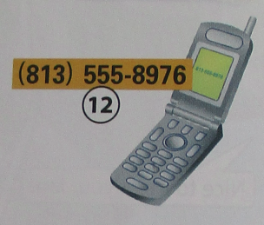  
    Nimewo telefòn selilè
17. Date of birth  
    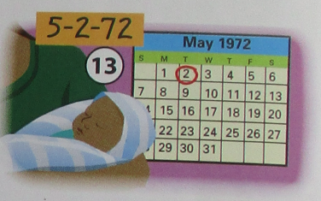  
    Dat nesans
18. Place of Birth  
    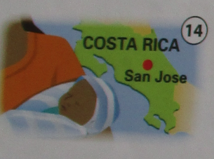  
    Kote ou fèt
19. Social Security number  
    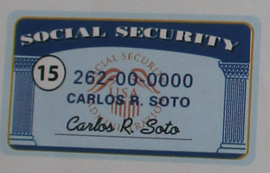  
    Nimewo Sekirite Sosyal
20. Sex  
    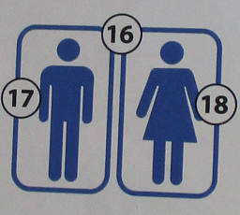  
    Sèks
21. Male  
      
    Gason
22. Female  
      
    Fi
23. Signature  
    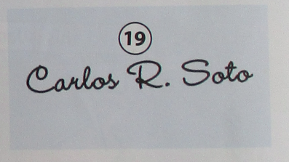  
    Siyati